Tasks on Load balancer
- Configure Classic Load balancer.
Created 2 instance and 1 VPC and then 2 subnets and then rt and IGW also then created a new ELB.
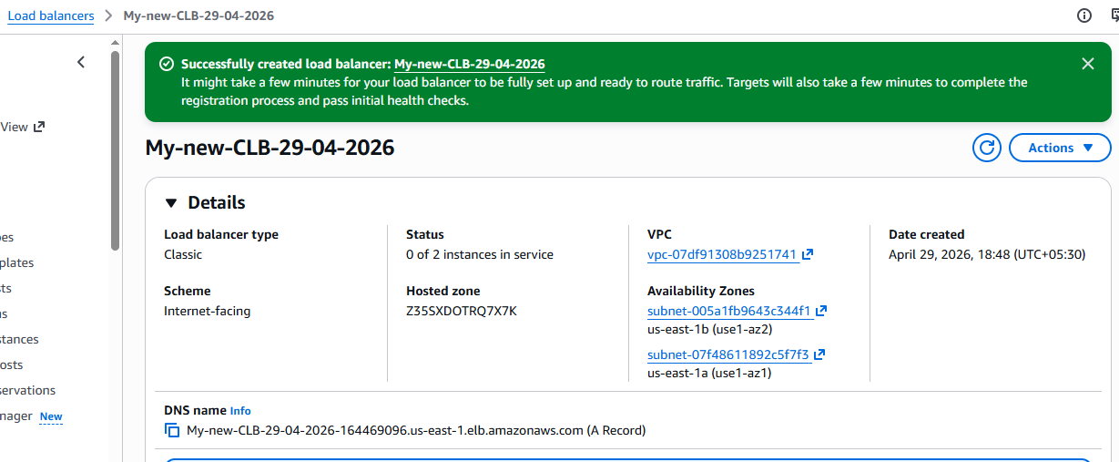
Connected the instance with git bash and then installed the Httpd and then checked the status of it. 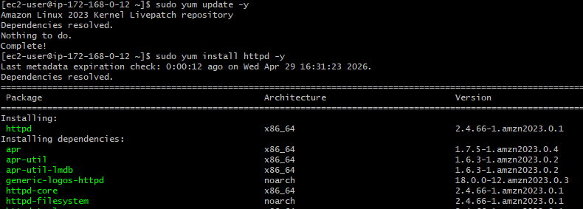 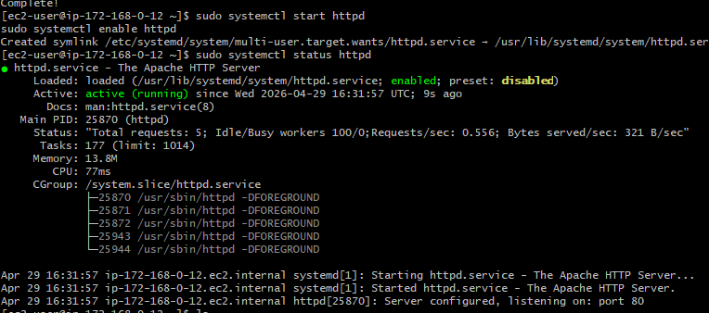
Changed the location as shown in the below image and then created a new file as index.html and then add content to it and then check with the ELB dns name and then hit enter in the browser by adding index.html: 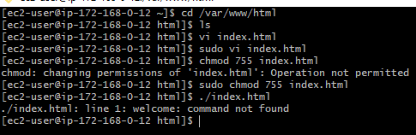 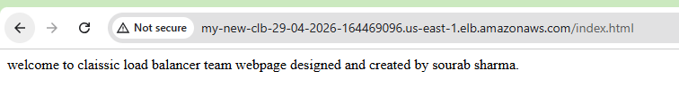 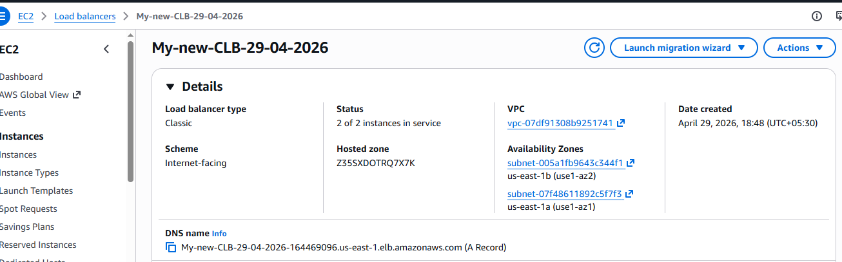
connected to the new instance after adding the pemkey in the first instance with name(new.pem) and then installed httpd and then did the same index.html step as shown above. 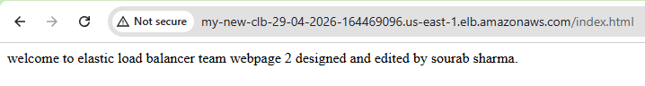
- Configure Application Load balancer.
firstly need to create a new target group if not available as shown below: 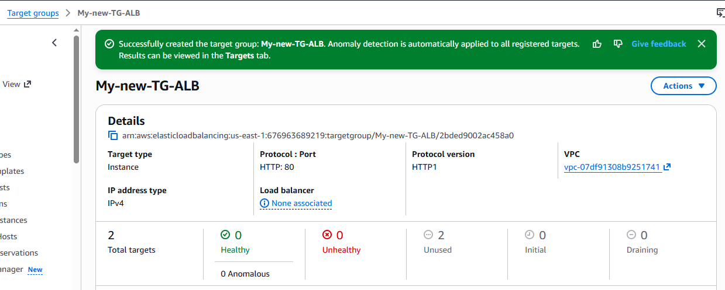
successfully created a new ALB and attached the 2 instance as well. 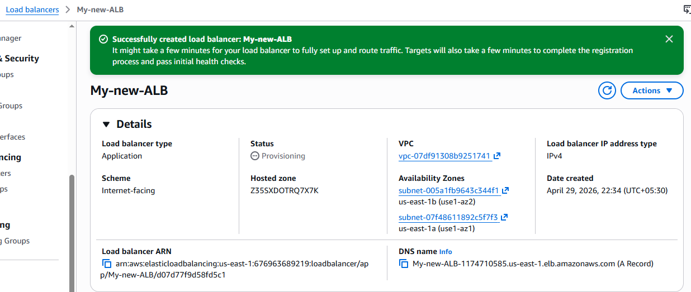
With the help of the DNS name in the new ALB directly able to divert the load from one instance to another by refreshing the page: 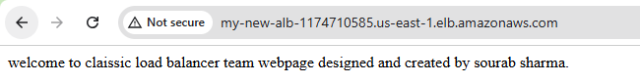 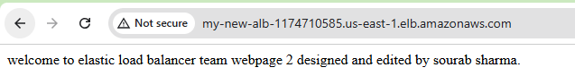
- Configure Network Load balancer.
Successfully created a new target group for NLB and attached the 2 instances to it.
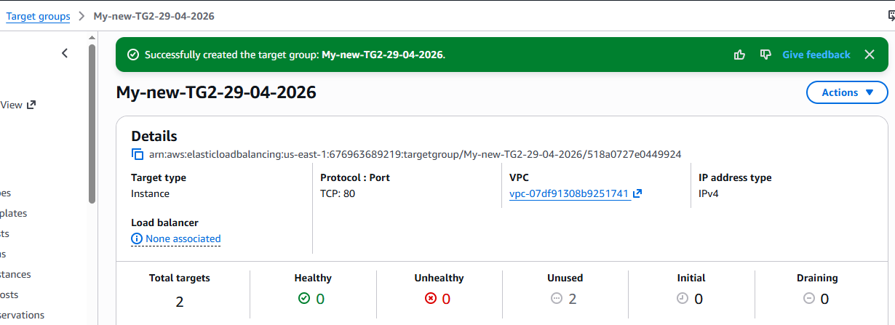
Then created a new NLB with the above created target group attached. 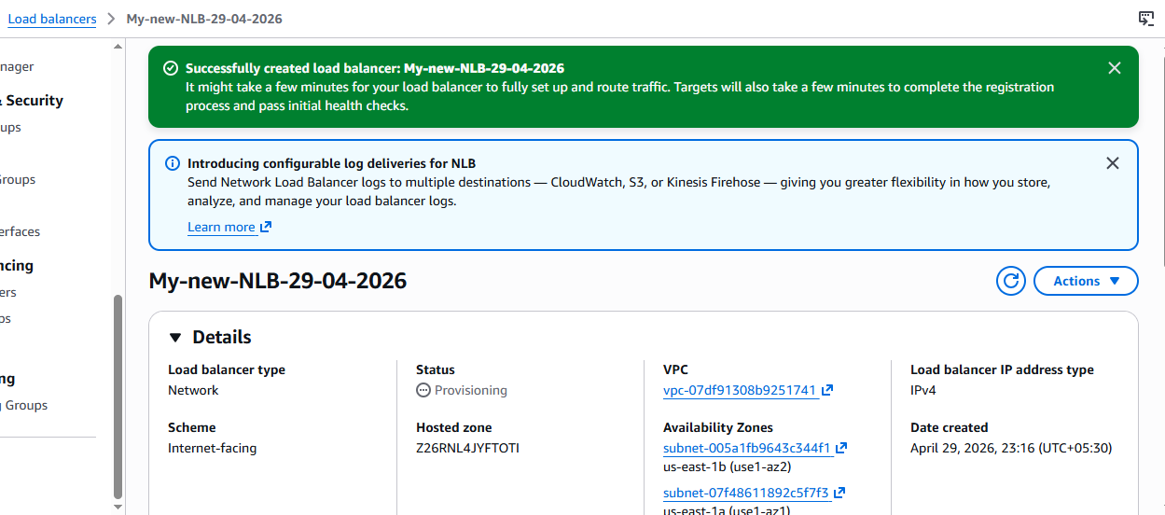 With the help of the DNS name in the new NLB directly able to divert the load from one instance to another by refreshing the page: 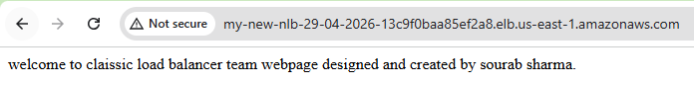
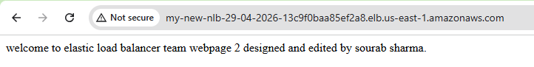
- Attach SSL for application load balancer.
Go to ACM and then request a certificate after entering the details and then wait until the status is shown as issued: 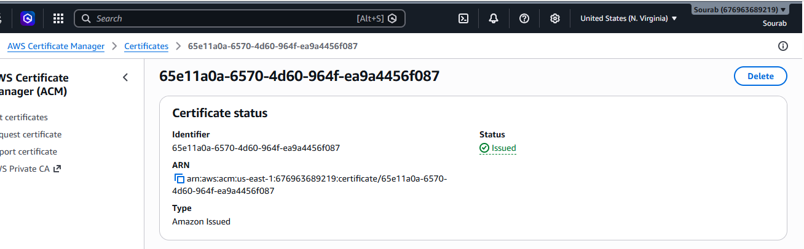
Then go to ALB and then click on listener’s option and then add listener and update details as provided below and also add the target group to is as well: 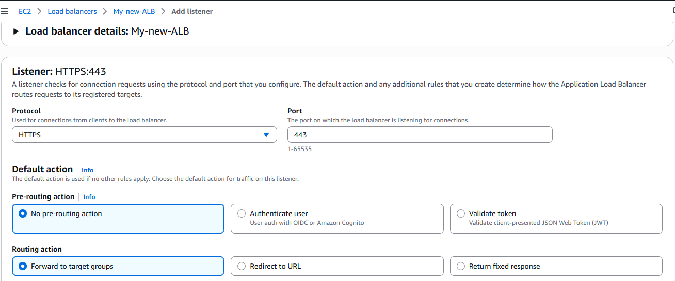
Then under secure listener setting’s add the domain name certificate like below from the ACM:
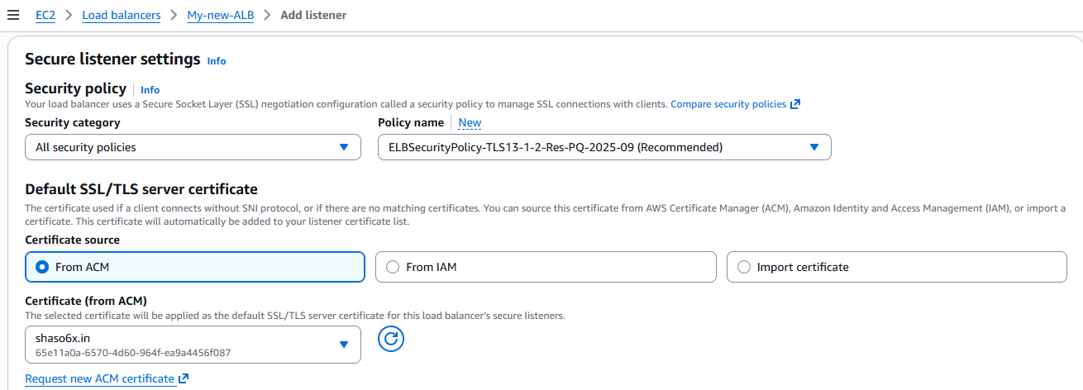
{Need to check whether the lock logo is showing up or not tomorrow. }
- Map Application load balancer to R53.
Created a new hosted zone after deleting the previous records and then added the required details as shown below in the records: 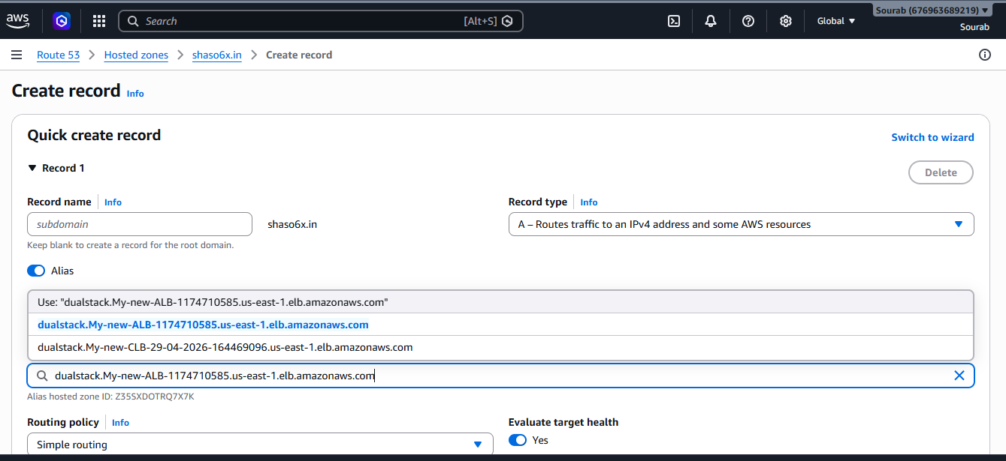
Need not to change the DNS server settings names in the Go daddy website as previous changes were already done, then check in the browser with the Domain name whether it is secure or not: 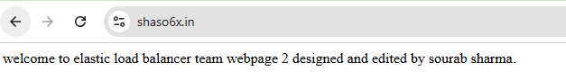
- Push the application load balancer logs to S3.
If you already have the s3 bucket then follow these steps:
Go to Amazon EC2 > In the left panel → Load Balancers > Select your Application Load Balancer > Go to Attributes tab > Click Edit attributes > Find Access logs > Enable it > Go to S3 bucket
s3://my-alb-logs-bucket-800/AWSLogs/676963689219/elasticloadbalancing/<region>/
